Web Application Development Log

Design Section

Project link on Github:
https://github.com/MrWardKKHS/shepard.git

Project name:
Shepherd

Project Summary: Include purpose and target audience
Rabobank has a Rural development fund – Each year 2 million is allocated to projects that aid the rural sector. This project is an attempt to follow this Kaupapa and raise the mauri of our rural workers.

Specifically – Shepard helps farm owners and apprentices connect. Farmhands, junior farmers, apprentice workers need a leg up from our senior veteran farmers with the knowledge and wisdom of years in rural service. Hopeful apprentices will be able to post a CV like profile and choose what kind of rural experience they are looking for (E.g. Dairy, beef, hort, fisheries). Farm owners will be able to list what kind of experience they are able to offer.

Junior workers and farm owners will be able to connect.

Initial Database Design ERD:
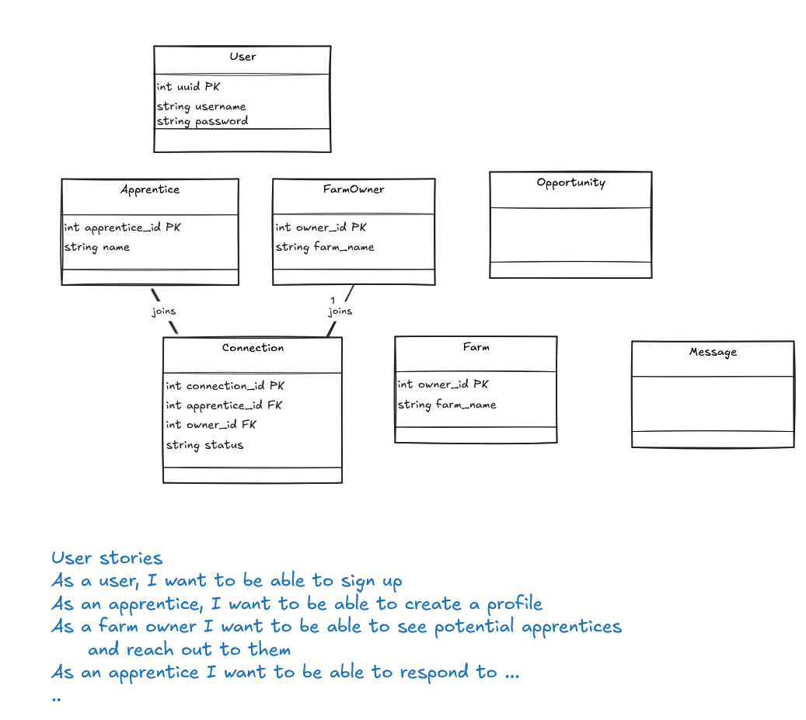

WebPage Design- Wireframe and/or Palette
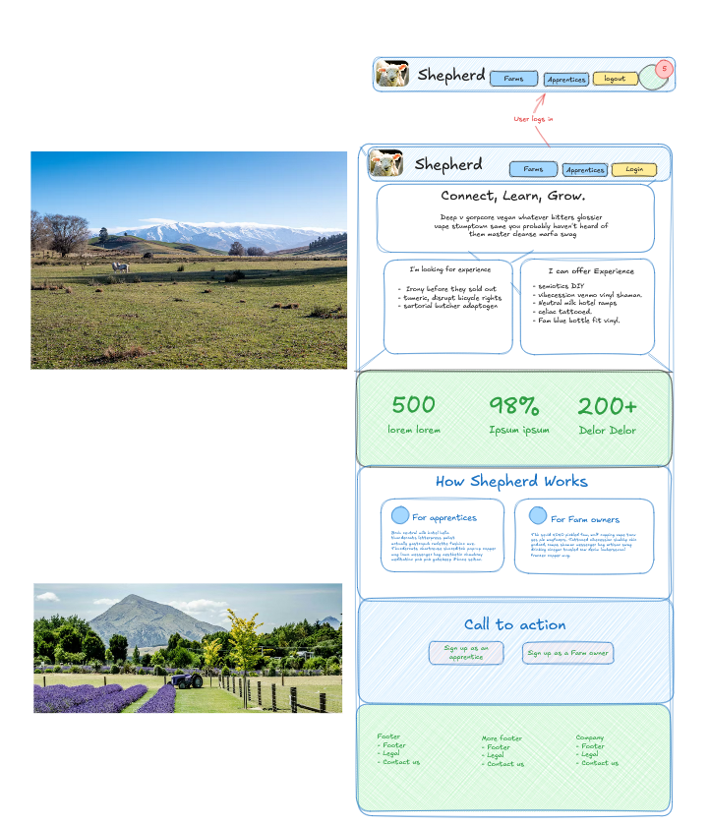

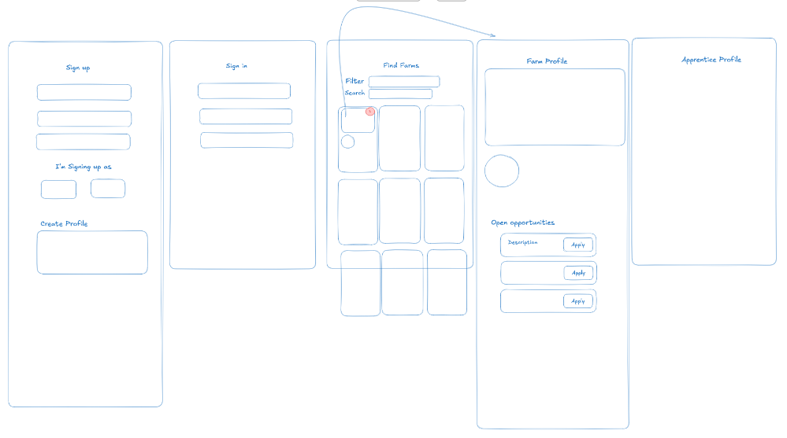

Relevant Implications (explain at least 3)- Before Development.

Sprint #1

Sprint #1 Goals
(before starting sprint 1):
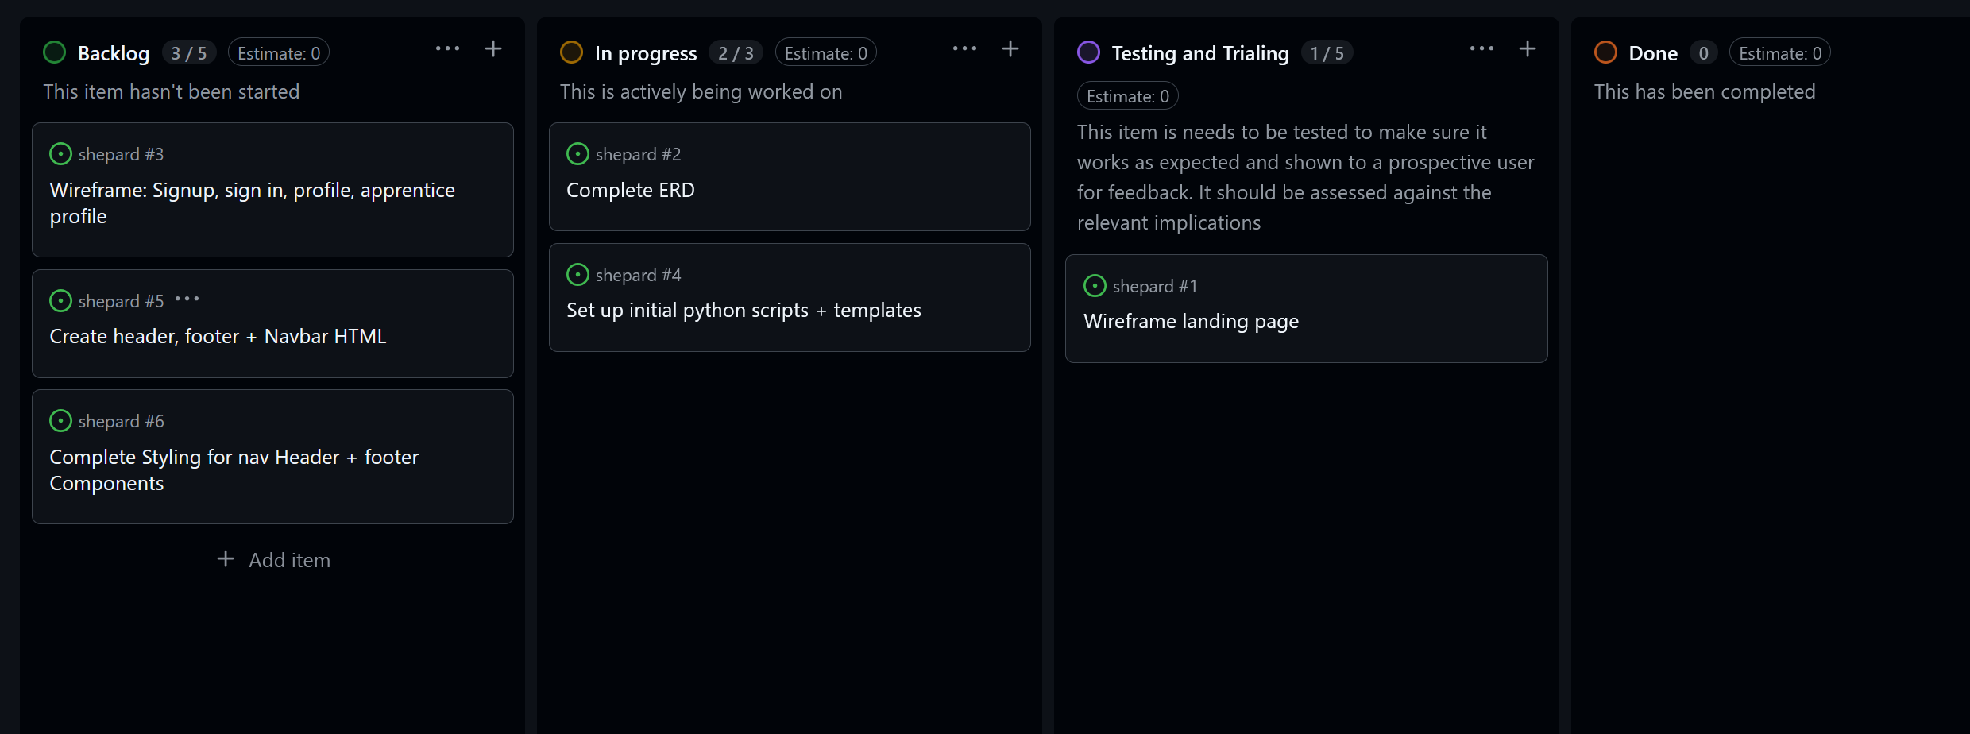

Finish my ERD

Sprint #1 Testing
Include tests for everything in your application including all links, input forms, correctness of data and correctness of queries. Add more columns as required.
Testing Table
What are you testing | How are you testing it | Expected Result | Pass/Fail

Sprint #1 Review
Progress Review (100+ words)

Sprint #2

Sprint #2 Goals
(before starting sprint):

Database improvements (if any otherwise delete box)
Entity Relationship Diagram

WebPage Design Improvements (if any)- Wireframe/Sketches/Pallette/Font etc

Sprint #2 Testing
Include tests for everything in your application including all links, input forms, correctness of data and correctness of queries. Add more columns as required.
Testing Table
What are you testing | How are you testing it | Expected Result | Pass/Fail

Sprint #2 Review
Progress Review (100+ words)

Sprint #3

Sprint #3 Goals
(before starting sprint):

Database improvements (if any)
Entity Relationship Diagram

WebPage Design Improvements (if any)- Wireframe/Sketches/Pallette/Font etc

Sprint #3 Testing
Include tests for everything in your application including all links, input forms, correctness of data and correctness of queries. Add more columns as required.
Testing Table
What are you testing | How are you testing it | Expected Result | Pass/Fail

Final Review
What were the results of your testing? Did you get through all that you expected to? What is causing problems? What went well? What was a challenge? What would you do differently if you had a chance?

Discuss how planning, testing and trialling led to the development of a high-quality digital technologies outcome.

How I addressed the Relevant Implications
As discussed before the project, what relevant implications had you identified at the beginning and how did you manage to address them as you went. Were there any others that you came across while making this game? How did you manage to address them? 100+ Words

Marking Schedules: For Teacher use only

AS91892- Use advanced techniques to develop a database
Credits: 4 (internal)
NZQA: https://www.nzqa.govt.nz/nqfdocs/ncea-resource/achievements/2019/as91892.pdf

Achieved- Develop a digital outcome to manage data | Evidence | ✔
designing the structure of the data | Made an ERD
using appropriate tools and techniques to structure, organise, query and present data for a purpose and end user | Competently normalized data structure  Multiple queries across linked tables  Basic Python CRUD functionality with text input/output
applying appropriate data integrity and testing procedures | Testing Logs. Do the queries work and return what is expected?
Explaining relevant implications. | Relevant Implications Questions answered appropriately
Merit- Develop an informed digital outcome to manage data
using information from testing procedures to improve the quality of the database | Suggested improvements implemented- improve database design, add or refine entities or tables and relationships  Made improved ERD(s)
structuring, organising and querying the data logically | No problems with structure and datatypes in the table. No wildcard queries, JOIN’s used efficiently.  2NF at least.
addressing relevant implications. | The outcome addresses the relevant implications mentioned
Excellence- Develop a refined digital outcome to manage data
iterative improvement throughout the design, development and testing process | Improved functionality of database and refinements to structure of the data.
presenting the data effectively for the purpose and to meet end-user requirements. | Very refined outcome providing all needed functionality

AS91893 - Use advanced techniques to develop a digital media outcome
Credits: 4 (Internal)
NZQA: https://www.nzqa.govt.nz/nqfdocs/ncea-resource/achievements/2019/as91893.pdf

Achieved | Evidence | ✔
using appropriate tools and techniques for the purpose and end users | Coded a website in HTML and CSS. Looks and functions mostly like intended in the design.
applying appropriate data integrity and testing procedures | It functions as intended and the right pages show with the correct data when the links are clicked
using relevant conventions for the media type | Site has basic usability (HCI)
explaining relevant implications. | Relevant conventions section completed adequately
Merit
using information from testing procedures to improve the quality of the outcome | Testing and sprint reviews show evidence of specific improvement made based on the testing. No lorem ipsum anymore!! Accurate Data
applying relevant conventions to improve the quality of the outcome | Decent HCI. Eg. generally shows “consistency and standards”, and/or “help and documentation” by having an about page.
addressing relevant implications. | Has met relevant implications like NOT used copyright material, addresses privacy by keeping data safe (eg hashed passwords) etc.
Excellence
iterative improvement throughout the design, development and testing process to produce a high-quality outcome | Must be high quality. No obvious errors or inaccurate data.
using efficient tools and techniques in the outcome’s production. | Kept a good log, used github to keep backups and record of work, lots of commits on github.

AS91896 - Use advanced programming techniques to develop a computer program

Credits: 6 (Internal)
NZQA: https://www.nzqa.govt.nz/nqfdocs/ncea-resource/achievements/2019/as91896.pdf

Achieved | Evidence | ✔
writing code for a program that performs a specified task | Applications works as intended.
using advanced techniques in a suitable programming language | “creating methods, functions, or procedures that use parameters and/or return values” flask requires that  “responding to events generated by a graphical user interface (GUI) ”- links in webpage run routes that do queries  “using additional non-core libraries”- using Flask.
setting out the program code clearly and documenting the program with comments | Some code comments, code layed out relatively cleanly with constants/variable at the top, routes and functions after.
testing and debugging the program to ensure that it works on a sample of expected cases. | Testing table shows the basic web page functionality was tested.
Merit
documenting the program with appropriate names and comments that describe code function and behaviour | Good variable and function names. Good and plentiful code comments.
following common conventions for the chosen programming language | PEP8 Followed. Use Pylint or similar and check linting.
testing and debugging the program effectively to ensure that it works on a sample of both expected cases and relevant boundary cases. | Lots of testing including request for non-existent id returning an error 404 page.
Excellence
ensuring that the program is a well-structured, logical response to the specified task | Enhanced program, e.g. functions that aren’t routes to make the code cleaner (eg query_db). Neat and logical code.
making the program flexible and robust | Great structure making code easy to extend. Unbreakable code. Eg. Error-404 and error 505 handlers
comprehensively testing and debugging the program. | Unbreakable code with a lot of tests done for every testable element of the program including unexpected input like a non existent route or page returning custom error 404 handler

